High-Speed Parallel Port
The EZ USB FX2 high-speed parallel port occupies ports B in 8-bit mode or ports B and D in 16-bit mode. It transfers data at a default clock rate of 48 MHz and by default performs 16-bit transfers only and outputs addresses on a 9-bit address bus on port C and bit 7 of port E.

These transfers are accomplished using the following QuickUSB Library functions:
QuickUsbReadData - Reads an arbitrary length of binary data to memory. The diagnostic program saves the memory blocks to a file.
QuickUsbWriteData - Writes an arbitrary length block of binary data to the high-speed parallel port. The diagnostic reads the data from the file and sends it as binary data.

The QuickUSB Library gives you to ability to send or receive data at high-speed in either 8 or 16 bit mode and with or without the aid of the address bus. In addition, future versions will support various timing models on the I/O port. Visit the website at http://www.quickusb.com for more information.

The high-speed parallel port tab is shown below:

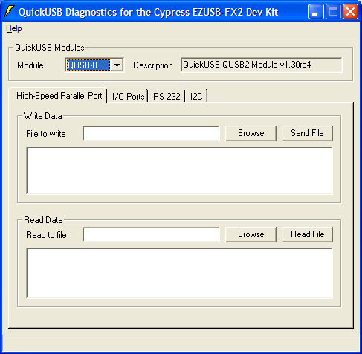

Write Data
File to Write
The fully qualified pathname of the file to write to the high-speed parallel port

Browse
Opens a browse window that you can use to select the file to write.

Send File
Send the selected file to the high-speed parallel port.

Read Data
File to Read
The fully qualified pathname of the file to read from the high-speed parallel port

Browse
Opens a browse window that you can use to select the filename of the to read.

Read File
Receives the selected file to the high-speed parallel port.

